**Topology**

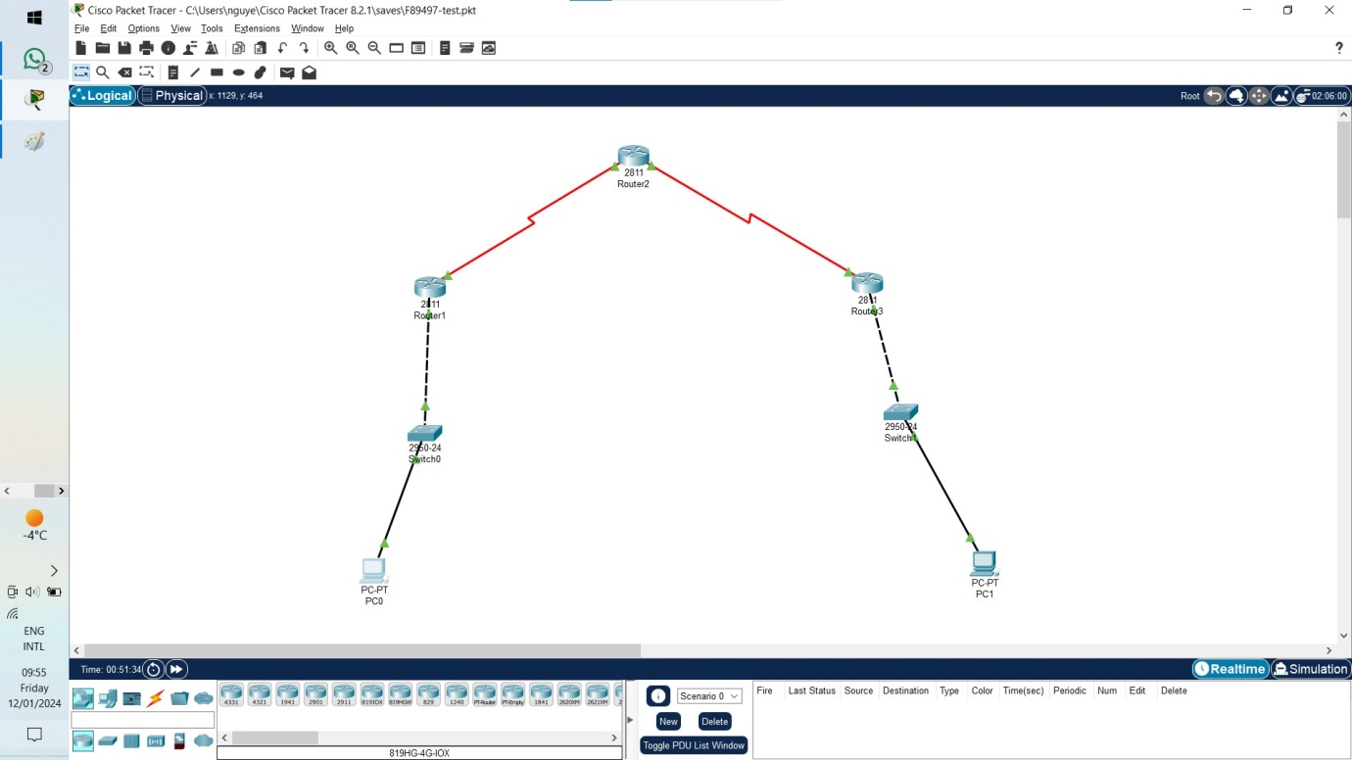

**PC-0 192.168.1.3 255.255.255.0 192.168.1.1 S1 Fa0/6**

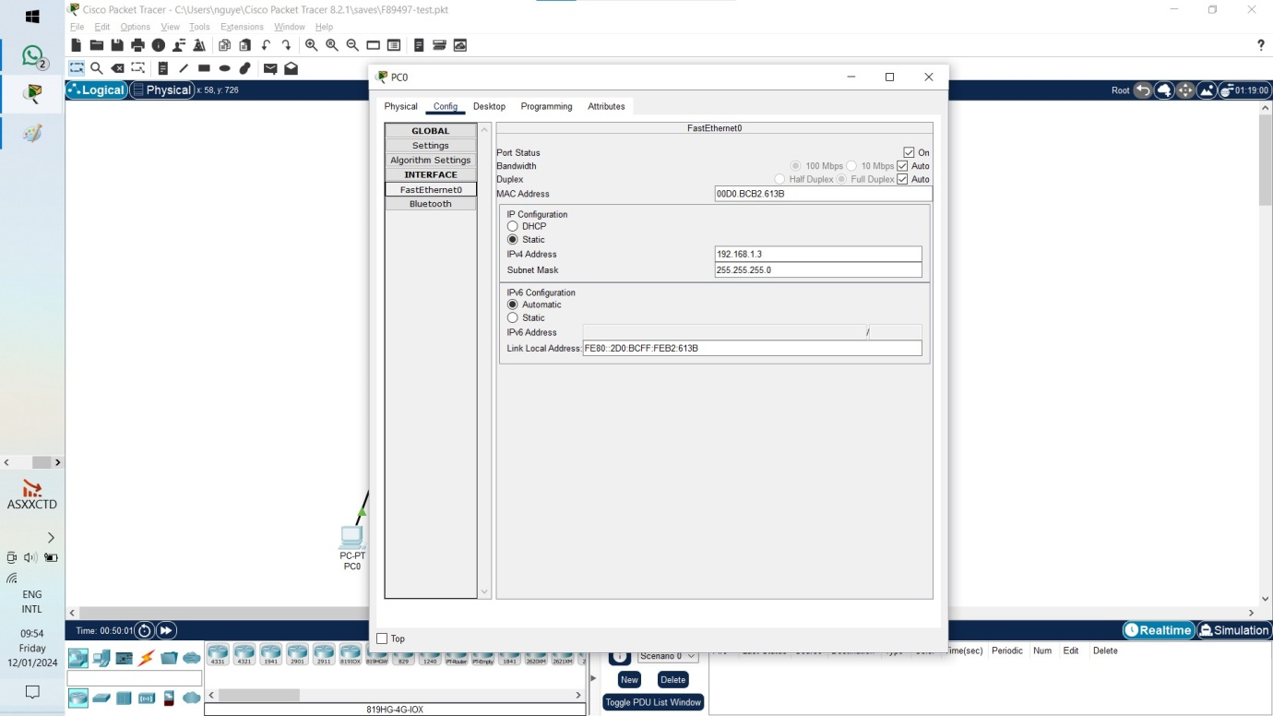

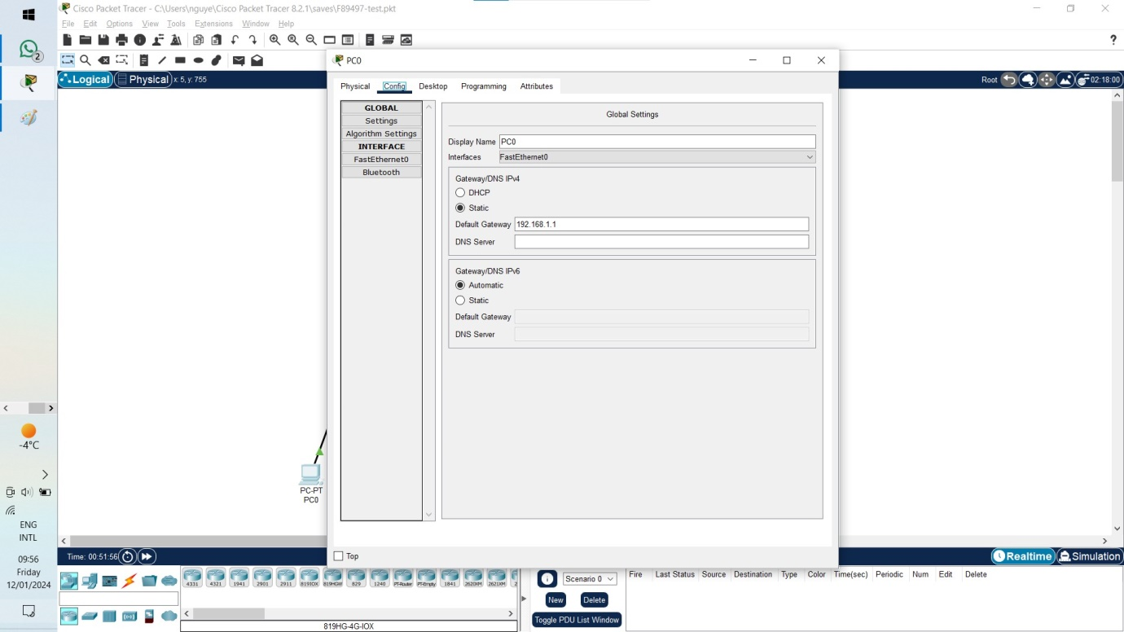

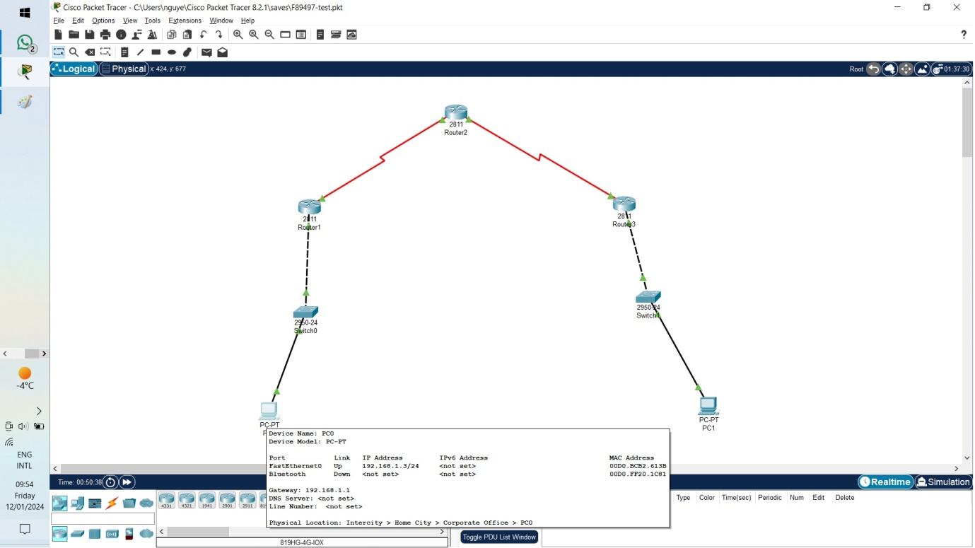

**PC-1 192.168.3.3 255.255.255.0 192.168.3.1 S3 Fa0/18**

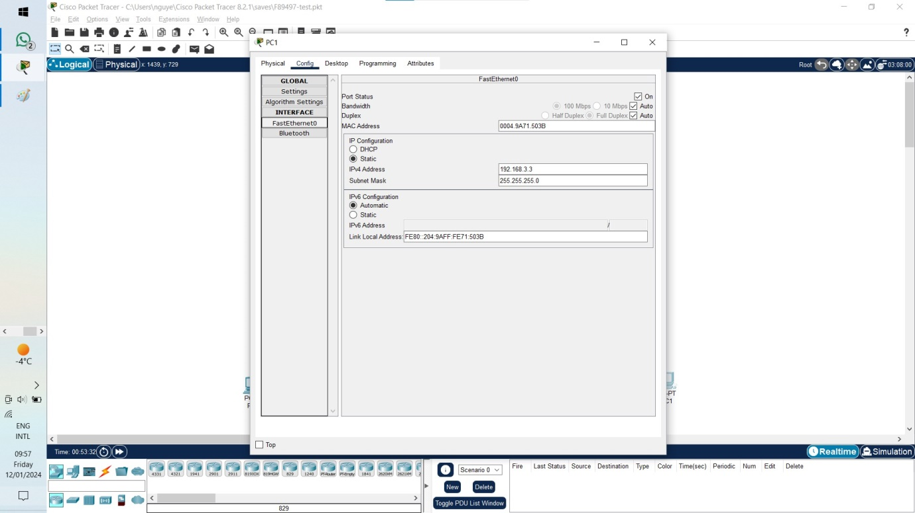

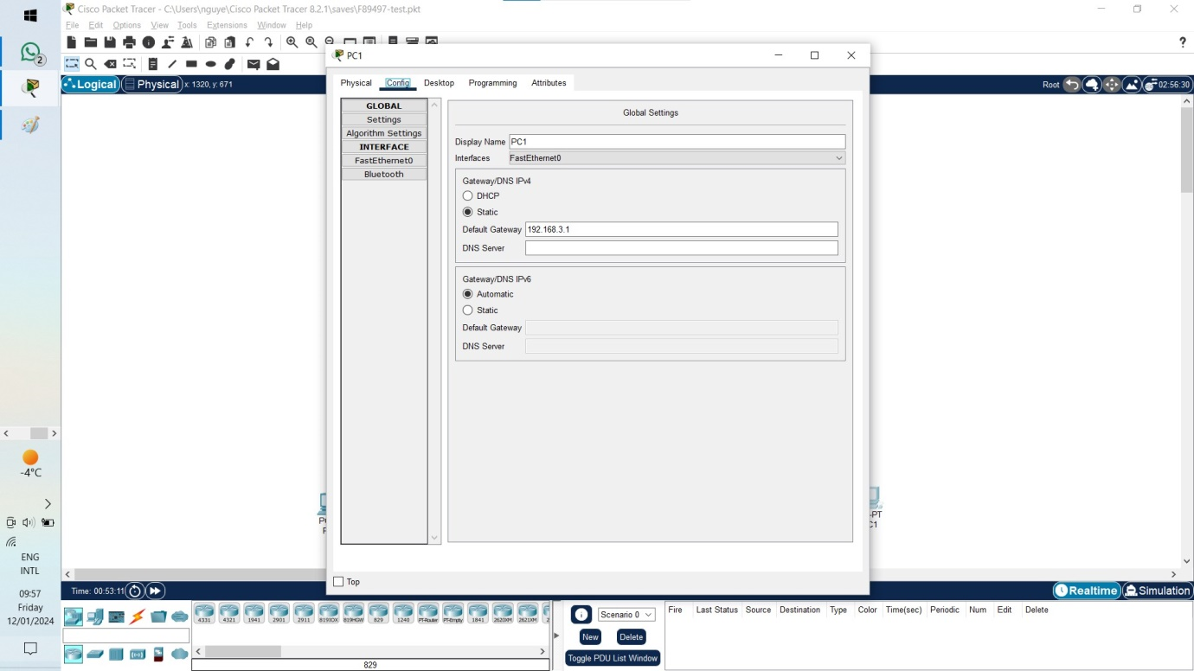

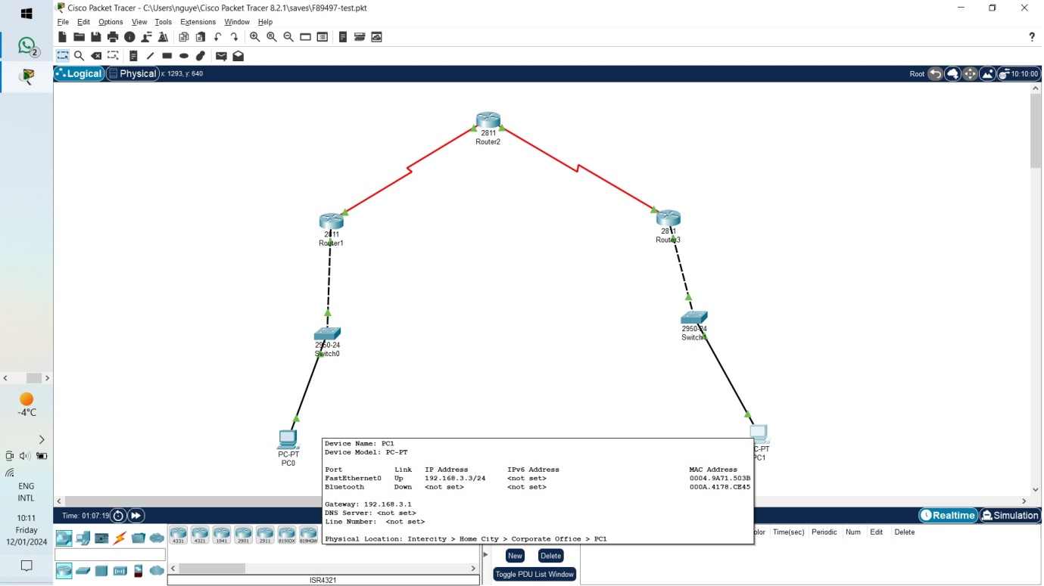

**Switches**

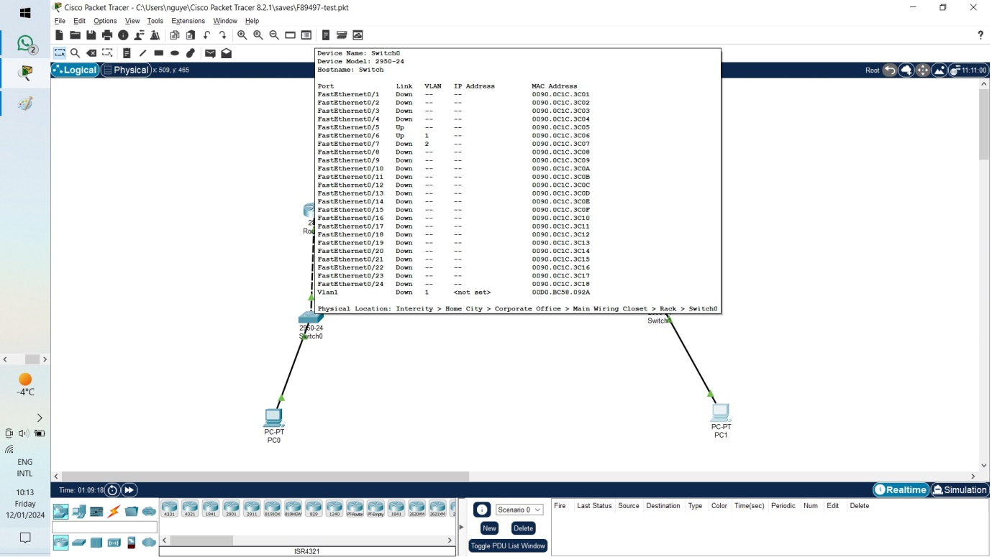

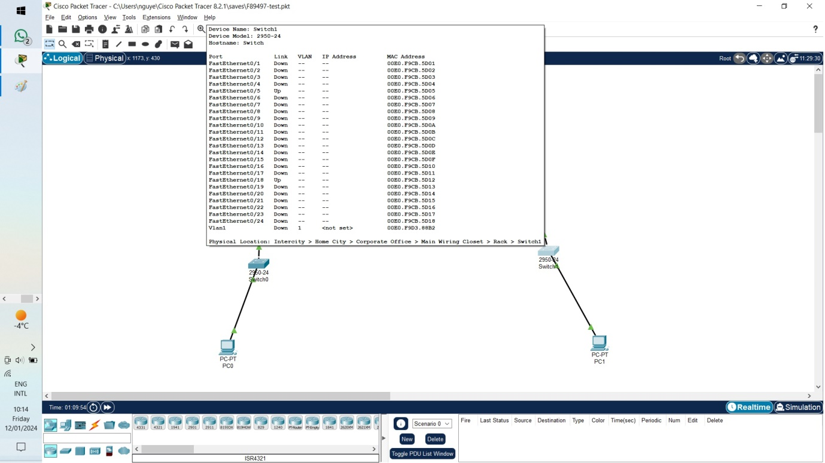

**R1 Fa0/1 192.168.1.1 255.255.255.0 S1 Fa0/5**

**S0/0/0 10.1.1.1 255.255.255.252**

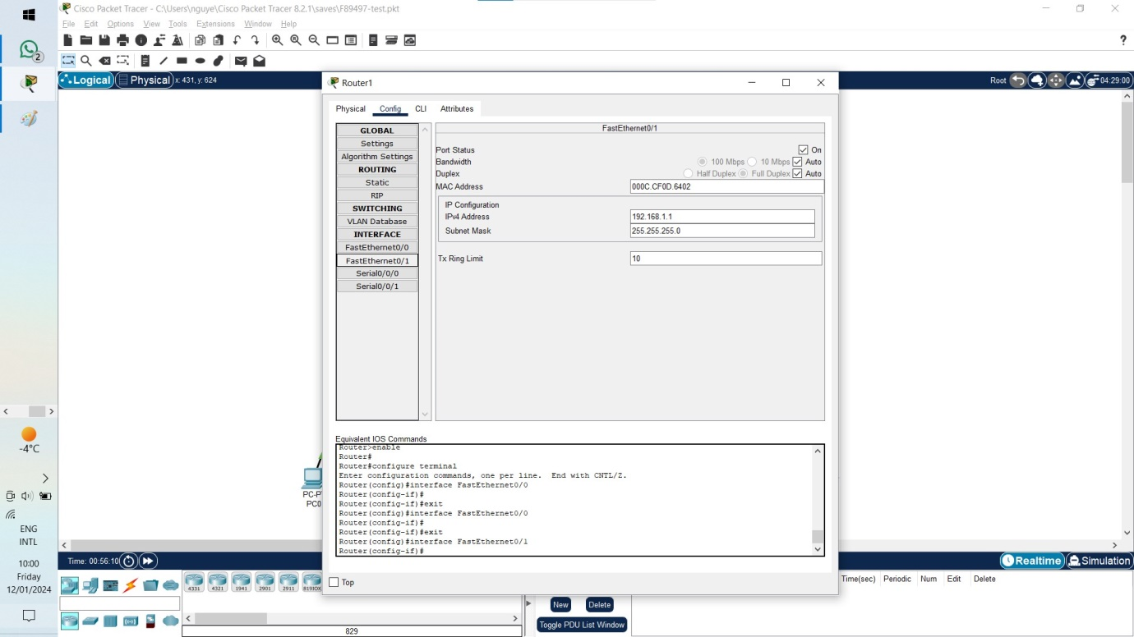

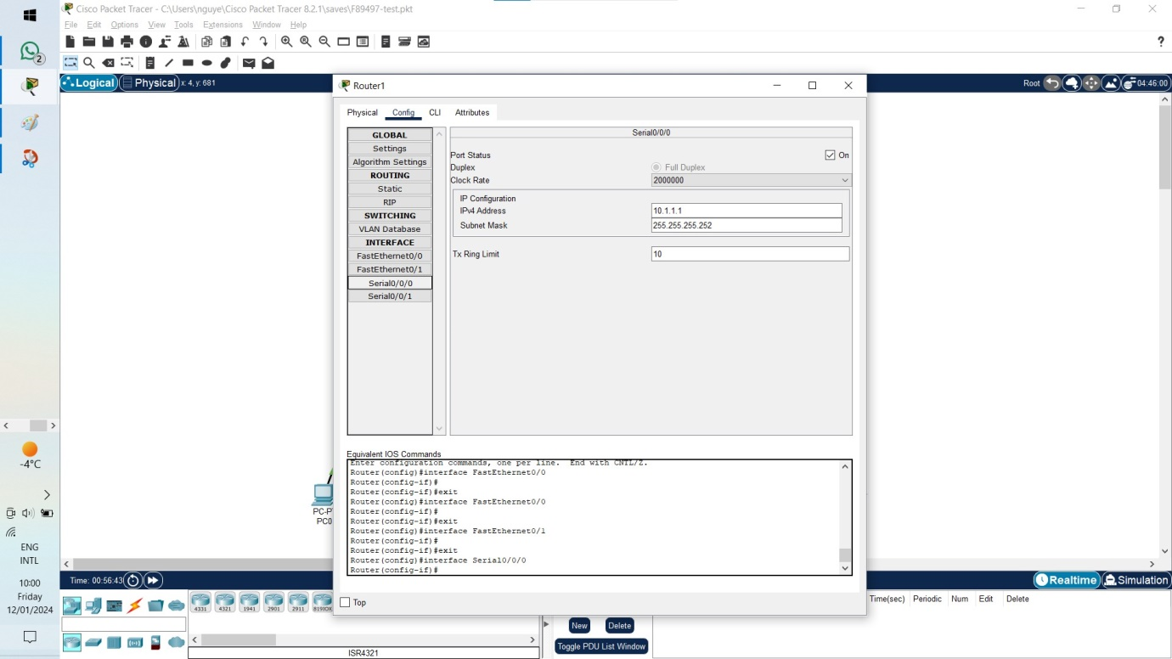

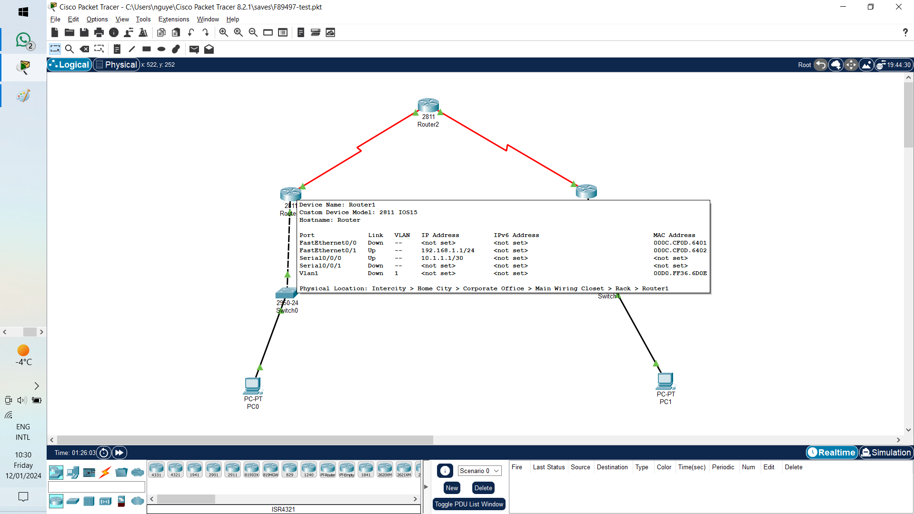

**R3 Fa0/1 192.168.3.1 255.255.255.0 S3 Fa0/5**

**S0/0/1 10.2.2.1 255.255.255.252**

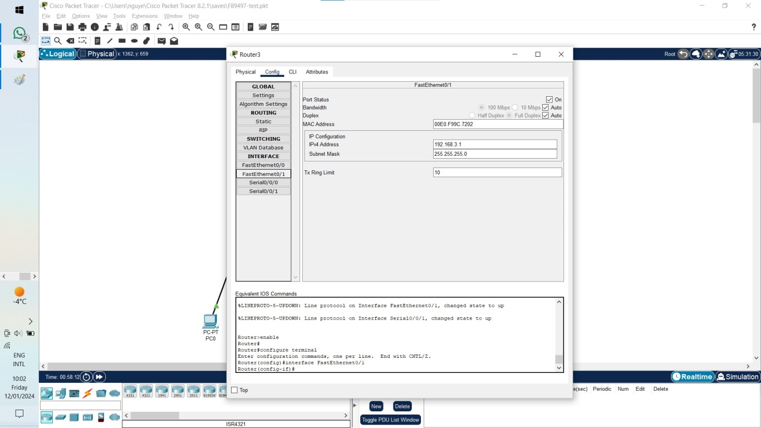

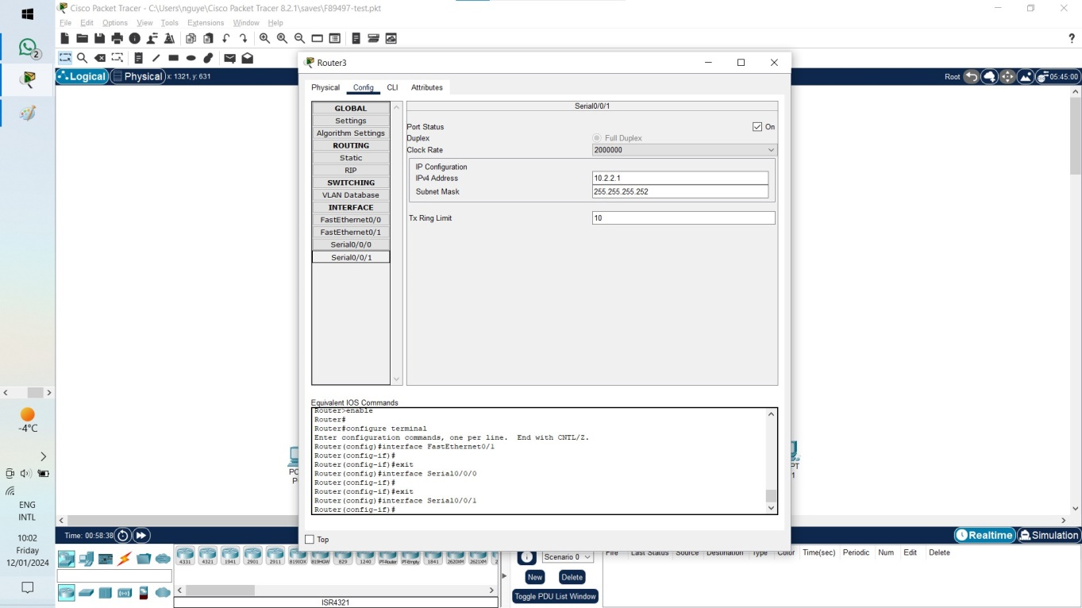

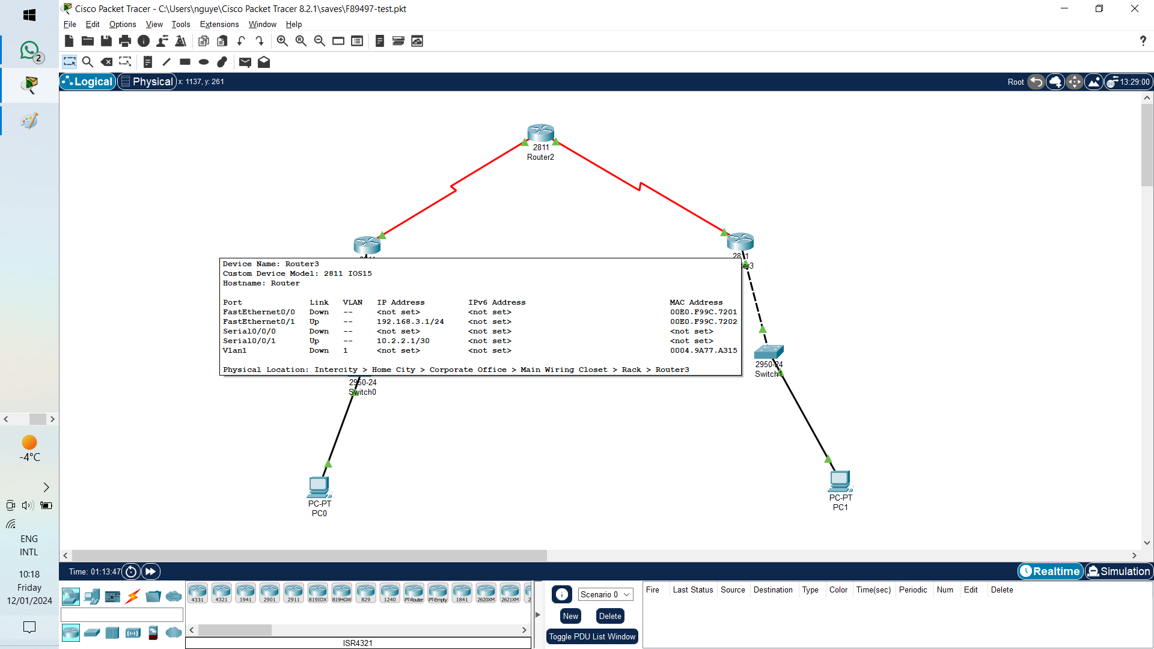

**R2 S0/0/0 10.1.1.2 255.255.255.252**

**S0/0/1 10.2.2.2 255.255.255.252**

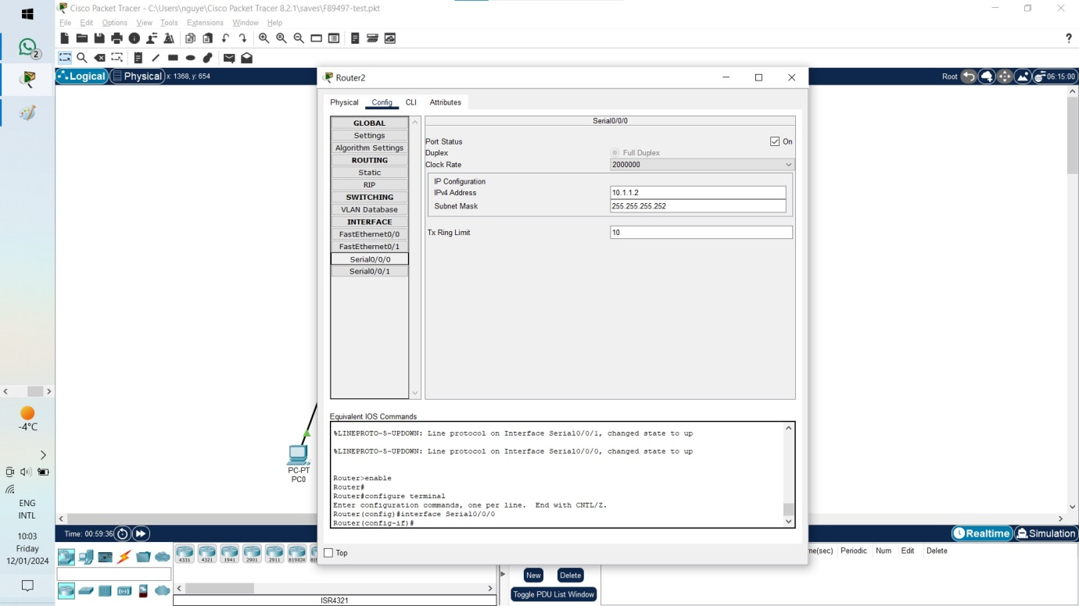

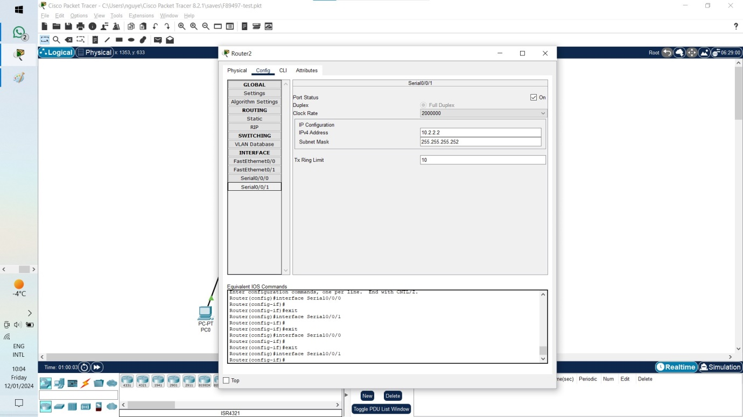

**Link file Cisco Packet Tracer:**

[**https://github.com/nguyen2uyet/phd/blob/main/Semester%201/INFM102%20%D0%9A%D0%BE%D0%BC%D0%BF%D1%8E%D1%82%D1%8A%D1%80%D0%BD%D0%B0%20%D1%81%D0%B8%D0%B3%D1%83%D1%80%D0%BD%D0%BE%D1%81%D1%82%20%D0%B2%20%D0%98%D0%BD%D1%82%D0%B5%D1%80%D0%BD%D0%B5%D1%82/F89497-test.pkt**](https://github.com/nguyen2uyet/phd/blob/main/Semester%201/INFM102%20%D0%9A%D0%BE%D0%BC%D0%BF%D1%8E%D1%82%D1%8A%D1%80%D0%BD%D0%B0%20%D1%81%D0%B8%D0%B3%D1%83%D1%80%D0%BD%D0%BE%D1%81%D1%82%20%D0%B2%20%D0%98%D0%BD%D1%82%D0%B5%D1%80%D0%BD%D0%B5%D1%82/F89497-test.pkt)